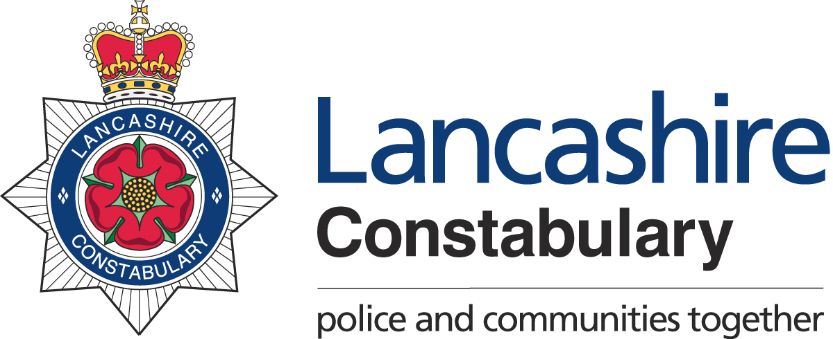

The Modern Slavery Act 2015 (the Act) came into force in July 2015 and it consolidates previous offences relating to slavery and human trafficking. It includes a provision for transparency in supply chains that requires all businesses with an annual turnover of £36 million or more to disclose, in an annual slavery and human trafficking statement on their website, what steps they have taken during the financial year to ensure their business and supply chains are slavery free. Companies and partnerships include trades or professions that supply goods or services.
Human trafficking involves children, women and men being recruited, harboured or brought into a situation of exploitation through the use of violence, deception or coercion and forced to work against their will.

Our business and our supply chains

As at 1st April 2018, Lancashire Constabulary and the Office of the Police and Crime Commissioner have a workforce of approximately 2936 Police Officers, 1745 Police Staff and 297 Police Community Support Officers. We can also call on the voluntary services of over 345 Special Constables and 240 volunteers. We are responsible for covering an area of 1187 square miles and a population of 1.47 million.

We buy a broad range of goods and services to meet the demands of modern policing; spending in excess of £46m each year on a wide range of categories of goods and services including ICT, Estates/Buildings, Criminal Justice Services, Fleet and Uniform. We have a commitment to ensure our supply chain is aware of the high ethical standards we demand.

Our commitment

As public bodies, the Police and Crime Commissioner and Chief Constable we will work in partnership with our suppliers to ensure that there is no modern slavery or human trafficking in the supply chain and encourage our suppliers to achieve high ethical standards and practices including fair and right working conditions across the supply chain.

- Our suppliers will be expected to demonstrate the highest of standards in relation to modern slavery, fair employment practices and ethical employment throughout their supply chains
- Encourage suppliers to use ethical supplier databases such as SEDEX (Supplier Ethical Data Exchange) or Ethical Labour Sourcing Framework (ELS) to document their practices and share that information with us
- All new and existing contracts will ensure that all our suppliers adhere to the requirements of the Modern Slavery Act 2015
- We will communicate a strict code of compliance and will not tolerate slavery and human trafficking within our supply chains
- The personnel who undertake procurement and contract management duties will be supported in reporting any breaches and implement appropriate measures
- Modern Slavery will form part of the contract management process for any high risk contracts with our key suppliers

