Police and Crime Commissioner for Lancashire
Treasury Management Strategy
2024/25

Police and Crime Commissioner for Lancashire
Treasury Management Strategy 2024/25
- Background
  - The Local Government Act 2003 (the Act) and supporting Regulations requires the Commissioner to “have regard to” the CIPFA Prudential Code and the CIPFA Treasury Management Code of Practice to set Prudential and Treasury Indicators for the next three years to ensure that the Commissioner’s capital investment plans are affordable, prudent and sustainable. Treasury management is defined in the CIPFA Codes as "The management of the organisation’s borrowing, investments and cash flows, including its banking, money market and capital market transactions, the effective control of the risks associated with those activities and the pursuit of optimum performance consistent with those risks."
  - The CIPFA Code includes the recommendation that authorities adopt the following:
    - Creation and maintenance of a Treasury Management Policy Statement which sets out the policies and objectives of the Commissioner’s treasury management activities, the current version is shown at Appendix 1.
    - Creation and maintenance of Treasury Management Practices which set out the manner in which the Commissioner will seek to achieve those policies and objectives. This is delegated to the Chief Finance Officer.
    - The production of an annual Treasury Management Strategy Statement - including the Annual Investment Strategy and Minimum Revenue Provision Policy - for the year ahead, a Mid-year Review Report and an Annual Report (stewardship report) covering activities during the previous year.
    - Delegation by the Commissioner of responsibilities for implementing and monitoring treasury management policies and practices and for the execution and administration of treasury management decisions.
  - The PCC has adopted the Code and also adheres to investment guidance issued by the then Ministry of Housing, Communities and Local Government (MHCLG). In 2018 the MHCLG issued new guidance which widens the definition of investments. For treasury management investments the guidance requires authorities to prioritise security, liquidity and yield in that order of importance. This is consistent with previous guidance. In addition, the guidance definition includes financial and non-financial assets which are held primarily or partially to generate a profit.
  - Where an authority holds non treasury investments it is required to produce a separate investment strategy. Although the definition is wide ranging covering loans to third parties, the holding of property to make a profit it is not considered that the PCC hold any such assets and it does not propose to engage in any such investments in 2024/25.
  - This strategy supports the Commissioner's Medium Term Financial Strategy (MTFS) along with the capital strategy and the reserves strategy.
  - This report fulfils the Authority’s legal obligation under the Local Government Act 2003 to have regard to both the CIPFA Code and the MHCLG Guidance.
- Reporting requirements
  - The following reporting arrangements will be adopted in accordance with the requirements of the revised Code:
Area of Responsibility | Responsible Officer | Frequency
Treasury Management Policy Statement | Police and Crime Commissioner | Annually before the start of the financial year.
Treasury Management Strategy / Annual Investment Strategy / MRP policy | Police and Crime Commissioner | Annually before the start of the financial year
Mid-year review, scrutiny of performance | Police and Crime Commissioner | Mid-year – 6 months
Treasury Management Strategy / Annual Investment Strategy / MRP policy – updates or revisions at other times | Police and Crime Commissioner | As required
Annual Treasury Management Outturn Report | Police and Crime Commissioner | Annually by 30 September
Treasury Management Monitoring Reports | Chief Finance Officer | Quarterly
Treasury Management Practices | Chief Finance Officer | Annually

- Treasury Management Strategy for 2024/25
  - In setting the Treasury Management Strategy, the following factors have been taken into account; economic forecasts, the level of the approved Capital Programme and the current structure of the Commissioner’s debt portfolio. It covers the following aspects of the Treasury Management function:
    - Prudential Indicators which will provide a controlling framework for treasury management activities.
    - Long-term debt outstanding.
    - Prospects for interest rates.
    - The Borrowing Strategy.
    - The Investment Strategy.
    - Policy on borrowing in advance of need.

Economic Context
- Economic background:
  - Key factors to consider in assessing the impact on the Strategy are the expectation for economic growth, inflation and the possible impact on interest rates.
  - The impact on the UK from higher interest rates and inflation, a weakening economic outlook, an uncertain political climate due to an upcoming general election, together with war in Ukraine and the Middle East, will be major influences on the Authority’s treasury management strategy for 2024/25.
  - The Bank of England (BoE) increased Bank Rate to 5.25% in August 2023, before maintaining this level in September and then again in November
  - The November quarterly Monetary Policy Report (MPR) forecast a prolonged period of weak Gross Domestic Product (GDP) growth with the potential for a mild contraction due to ongoing weak economic activity. The outlook for CPI inflation was deemed to be highly uncertain, with near-term risks to CPI falling to the 2% target coming from potential energy price increases, strong domestic wage growth and persistence in price-setting.
  - The UK economy grew by 0.2% between April and June 2023. The BoE forecasts GDP will likely stagnate in Q3 but increase modestly by 0.1% in Q4, a deterioration in the outlook compared to the August MPR. The BoE forecasts that higher interest rates will constrain GDP growth, which will remain weak over the entire forecast horizon.
  - Office for National Statistics (ONS) figures showed CPI inflation was 6.7% in September 2023, unchanged from the previous month but above the 6.6% expected. Core CPI inflation fell to 6.1% from 6.2%, in line with predictions. Looking ahead, using the interest rate path implied by financial markets the BoE expects CPI inflation to continue falling, declining to around 4% by the end of calendar 2023 but taking until early 2025 to reach the 2% target and then falling below target during the second half 2025 and into 2026.
- Arlingclose Forecast
  - The Bank of England (BoE) increased the Bank Rate to 4% in February 2023. This has been part of a cycle of increases that has seen the base rate increase from 0.25% in December 2021.
  - The Commissioner’s treasury management adviser Arlingclose forecasts that although UK inflation and wage growth remain elevated, that Bank Rate has peaked at 5.25%.
  - The Bank of England’s Monetary Policy Committee will cut rates in the medium term to stimulate the UK economy but will be reluctant to do so until it is sure there will be no lingering second-round effects. Arlingclose sees rate cuts from Q3 2024 to a low of around 3% by early to mid-2026.
  - Arlingclose expects long-term gilt yields to eventually fall from current levels (amid continued volatility) reflecting the lower medium-term path for Bank Rate. However, yields will remain relatively higher than in the past, due to quantitative tightening and significant bond supply. As ever, there will undoubtedly be short-term volatility due to economic and political uncertainty and events.
  - Like the BoE, the Federal Reserve and other central banks see persistently high policy rates through 2023 and 2024 as key to dampening domestic inflationary pressure. Bond markets will need to absorb significant new supply, particularly from the US government.
  - The latest forecast is shown in the table below:
 | Bank Rate % | 3-month money market rate% | 5-year gilt yield % | 10-year gilt yield % | 20-year gilt yield % | 50-year gilt yield %
Current | 5.25 | 5.40 | 3.75 | 3.75 | 4.20 | 3.80
Mar-24 | 5.25 | 5.40 | 3.75 | 3.80 | 4.20 | 3.85
Jun-24 | 5.25 | 5.30 | 3.75 | 3.80 | 4.20 | 3.90
Sep-24 | 5.00 | 5.15 | 3.70 | 3.80 | 4.20 | 3.90
Dec-24 | 4.75 | 4.80 | 3.60 | 3.80 | 4.20 | 3.90
Mar-25 | 4.25 | 4.30 | 3.50 | 3.80 | 4.20 | 3.90
Jun-25 | 4.00 | 4.10 | 3.50 | 3.80 | 4.20 | 3.90
Sep-25 | 3.75 | 3.80 | 3.40 | 3.75 | 4.20 | 3.90
Dec-25 | 3.50 | 3.50 | 3.30 | 3.65 | 4.20 | 3.90
Mar-26 | 3.25 | 3.25 | 3.30 | 3.60 | 4.20 | 3.95
Jun-26 | 3.00 | 3.05 | 3.30 | 3.65 | 4.20 | 3.95
Sep-26 | 3.00 | 3.05 | 3.35 | 3.70 | 4.25 | 3.95

  - In the above table 'bank rate' refers to the policy rate of the Bank of England. PWLB borrowing rates are based on 'Gilt Yield' and so this is a forecast of long-term interest rates. The Authority can borrow at 80 basis points above the gilt yield, so for example a fixed interest rate to borrow PWLB money for 10 years would be 4.45%, 3.75% plus 0.80%.

Current Position
- Current Treasury Portfolio Position
  - The value of the Commissioner's Treasury Portfolio at 31.12.2023 is:
Principal
£m
DEBT
Fixed rate loans from PWLB | 42.400
Fixed term loans from other local authorities | 35.000
Total debt | 77.400
INVESTMENTS
Variable rate investments with the County Council | 6.342
Total investments | 6.342
Net (debt)/Investments | (71.058)

  - The level of investments represents the Commissioner’s cumulative surplus on the General Fund, the balances on other cash-backed earmarked reserves and a cash-flow balance generated by a surplus of creditors over debtors and by grant receipts in advance of payments.
- Borrowing Requirement
  - In the medium term the PCC borrows for capital purposes only. The underlying need to borrow for capital purposes is measured by the Capital Financing Requirement (CFR), while usable reserves and working capital are the underlying resources available for investment. The table below compares the estimated CFR to the debt which currently exists. This gives an indication of the borrowing required. It also shows the estimated resources available for investment. An option is to use these balances to finance the expenditure rather than investing, often referred to as internal borrowing, so the table gives an indication of the minimum borrowing requirement through this method.
  - The CFR has been calculated adopting a policy that the Commissioner has set aside revenue reserves and contributions to contribute to the delivery of the investment included in the Capital Programme. This resource will be used, in the first instance, to provide finance for short life assets such as IT systems and equipment in order to avoid the use of borrowing where possible for this type of asset. The Commissioner's strategy increases the revenue budget each year in respect of the contribution made to finance the capital programme. This approach reflects the reduction in earmarked reserves available for funding the capital programme and represents a prudent strategy for the funding of short life assets. This approach is taken because the annual cost of borrowing over shorter terms is more expensive than for longer periods due to the higher MRP repayment and the use of revenue contributions and reserves to minimise such shorter life borrowing represents better value for money.
  - The CFR forecast includes the impact of the latest forecast of the funding of the Capital Programme.
 | 31/3/2024 | 31/3/2025 | 31/3/2026 | 31/3/2027
 | £m | £m | £m | £m
Capital Financing Requirement | 90.029 | 135.496 | 176.752 | 200.697
Less external borrowing | 92.325 | 45.850 | 39.375 | 38.400
Borrowing requirement | -2.296 | 89.656 | 137.377 | 162.297
Reserves and working capital | -3.789 | -3.539 | -3.289 | -3.039
Borrowing/(investment) need | -6.085 | 86.107 | 134.088 | 159.259

  - The current borrowing forecast at 31 March 2024 is above the projected CFR at year end however this is due to borrowing being taken in advance for the capital programme borrowing requirements in 2024/25.
- Liability benchmark
  - To compare the Council’s actual borrowing against an alternative strategy, a liability benchmark has been calculated showing the lowest risk level of borrowing. This assumes the same forecasts as the table above, but that cash and investment balances are kept to a minimum level of £10m at each year-end to maintain sufficient liquidity but minimise credit risk. The liability benchmarks are shown in the graph below:
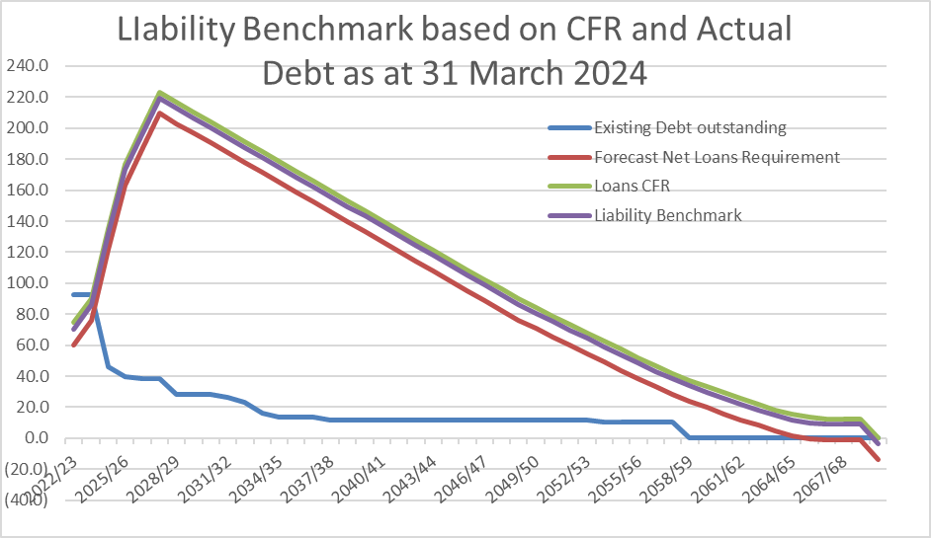

  - The liability benchmark graph above shows that there is an actual need to undertake borrowing in 2024/25 and beyond until at least 2060/61 based upon the current capital programme so consideration will be given to undertake some long-term borrowing in the next few years.
- Borrowing Strategy
  - The data shown above demonstrates that the Commissioner does have a significant borrowing requirement both in the short and long term. This requirement could be met by taking a series of long-term loans. However, this may be too simplistic an approach as there will be some internal resources that could be used to replace borrowing especially as the receipt of income is not even during the year. The diagram below shows the cashflow forecasts for 2024/25 before any further borrowing decisions are taken:
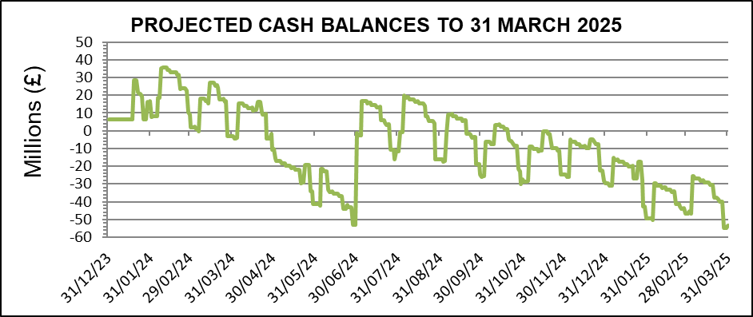

  - The graph illustrates there are times when cash flow is negative and therefore short-term loans could be used to meet the borrowing need in the year. However, as capital expenditure is incurred over the next few years this will becoming increasingly difficult.
  - It is therefore anticipated that the borrowing strategy will be to meet requirements by a mixture of long and short-term borrowing. Short-term borrowing is generally cheaper in year but there is the risk that future replacement loans will be more expensive. Therefore, consideration will be given to both debt maturity profile and the latest interest rate forecasts to assess whether long or short-term borrowing is taken.
  - The table below shows the maturity profile of the existing debt of £87.4m in 2024/25:
Years to maturity from 1.4.24 | Debt £m | %
Under 1 Year | 41.4 | 47.4
1 -2 Years | 6.4 | 7.3
2-5 years | 10.9 | 12.5
5-10 years | 12.0 | 13.7
Over 10 years | 16.7 | 19.1

  - This illustrates that the portfolio does have a reasonable proportion of long-term debt to mitigate refinancing risk while taking some of the benefits of short-term borrowing.
  - The interest rates and Gilt rates, which determine PWLB loan rates, forecasts shown earlier in the report show rates are expected to remain at fairly constant levels albeit there may be some small reductions from March 2025. If there was an expectation that long-term rates were due to increase sharply then it is likely that more long-term loans would be taken. The situation will be constantly reviewed by County Councils Treasury Management Team and the OPCC Chief Finance Officer.
  - In undertaking borrowing the approved sources of long-term and short-term borrowing currently are:
    - Public Works Loan Board
    - UK local authorities
    - any institution approved for investments.
    - any other bank or building society authorised by the Prudential Regulation Authority to operate in the UK.
    - UK public and private sector pension funds
  - It is proposed that this will continue. In the past the Commissioner has raised all long-term borrowing from the Public Works Loan Board, but he continues to investigate other sources of finance, such as local authority loans and bank loans, that may be available at more favourable rates.
- Debt Restructuring
  - The Chief Finance Officer, together with the County Council's treasury management team reviews options for debt restructuring on a regular basis. A recent review found that given the relatively favourable interest rates at which these have been taken out (below 5%) and the penalties associated with any early repayment, restructure is not considered financially viable at the present time. A better option for the immediate future is to continue to utilise reserves to minimise the future borrowing requirement rather than repay debt.
  - Frequent discussions will continue to take place between the Chief Finance Officer and the Treasury Management Team to monitor this situation and any future decisions on debt financing will be put through the same rigorous cost and prudence analysis that external borrowing has traditionally gone through and will be reported to the Commissioner in due course.
- Policy on Borrowing in Advance of Need
  - The Commissioner will not borrow more than or in advance of need purely in order to profit from the investment of the extra sums borrowed. However advance borrowing may be taken if it is considered that current rates are more favourable than future rates and that this advantage outweighs the cost of carrying advance borrowing. Any decision to borrow in advance will be considered carefully to ensure value for money can be demonstrated and that the Commissioner can ensure the security of such funds.
  - In determining whether borrowing will be undertaken in advance of need the Commissioner will:
- Ensure that there is a clear link between the capital programme and the maturity profile of the existing debt portfolio which supports the need to take funding in advance of need.
- Ensure the ongoing revenue liabilities created, and the implications for the future plans and budgets have been considered.
- Evaluate the economic and market factors that might influence the manner and timing of any decision to borrow.
- Consider the merits and demerits of alternative forms of funding.
- Consider the alternative interest rate bases available, the most appropriate periods to fund and repayment profiles to use.
- Treasury Management Investment Strategy
  - The Commissioner will have regard to the MHCLG’s Guidance on Local Government Investments and the revised CIPFA Treasury Management in Public Services Code of Practice and Guidance Notes (“the CIPFA TM Code”). The Commissioner’s investment priorities are:
    - The security of capital and
    - The liquidity of its investments.
  - The Commissioner will also aim to achieve the optimum return on his investments commensurate with proper levels of security and liquidity. The risk appetite of the Commissioner is low in order to give priority to security of its investments.

- Current Investments
  - On 31 December 2023 the Commissioner held £6.342m invested funds, representing income received in advance of expenditure plus balances and reserves held. During 2023/24 the Commissioner’s investment balance has averaged at £52.447m, with the highest balance being £95.637m. The Commissioner will only use very high-quality counterparties for investments.
  - The Commissioner's investments are principally held with LCC with the other investments being fixed term deposits with other local authorities. On 31 December the investment balances were solely made up from £6.342m held with LCC.
  - The Commissioner currently has access to a call (instant access) account with LCC. This currently pays bank rate, (currently 5.25%). Each working day the balance on the Commissioner's Current Account is invested in this to ensure that the interest received on surplus balances is maximised.
  - The interest earned during the year as of 31 December 2023 is £1.933m at an annualised rate of 4.89%. This matches with the benchmark 7-day LIBID which averages a yield of 4.89% over the same period.
  - Investment Counterparties
    - With the security and liquidity being key drivers of the investment strategy, it is expected that a call account facility will remain a key part of the investments. However, the Commissioner can invest with other local authorities. Arlingclose, the Commissioner's Treasury Management advisor, state they are "comfortable with clients making loans to UK local authorities for periods up to two years, subject to this meeting their approved strategy. For periods longer than two years we recommend that additional due diligence is undertaken prior to a loan being made."
    - On this basis it is proposed that the investments to local authorities are limited as follows:
 | Maximum individual investment (£m) | Maximum total investment (£m) | Maximum period
Up to 2 years | 10 | 250 | 2 years
Over 2 years | 10 | 50 | 10 years

  - The investment in LCC as part of the call account arrangement is excluded from the above limits. The balance on this account is dependent upon short term cash flows and therefore does not have a limit.
  - The Commissioner may invest surplus funds with any of the counterparties in the table below, subject to the cash and time limits shown.
Counterparty |  | Cash limit | Time limit
Secured Bank Deposits, Reverse repurchase Agreements | AAA | £5m each | 5 years*
 | AA+ |  | 3 years*
 | AA |  | 2 years*
 | AA- |  | 2 years*
Call Accounts with banks and other organisations with minimum AA- credit rating |  | £10m | next day
UK Central Government (irrespective of credit rating) |  | unlimited | 50 years**
UK Local Authorities (irrespective of credit rating) |  | £10m | 10 years
Call Account facility |  | unlimited | Next day
Secured Bond Funds AA rating and WAL not more than 3 years |  | £5m each | n/a
Secured Bond Funds AAA rated and WAL not more than 5 years |  | £5m each | n/a
* But no longer than 2 years in fixed-term deposits and other illiquid instruments
** but no longer than 5 years in fixed-term deposits and other illiquid instruments
  - Whilst the investment strategy allows flexibility with investments any decision as to whether to utilise this facility will be made based on an assessment of risk and reward undertaken jointly between the Chief Finance Officer and LCC Treasury Management Team, and consideration of this forms part of the on-going meetings that take place throughout the year.
  - The Commissioner may lend or invest money using any of the following instruments:
    - interest-bearing bank accounts,
    - fixed term deposits and loans,
    - callable deposits where the Commissioner may demand repayment at any time (with or without notice),
    - certificates of deposit,
    - bonds, notes, bills, commercial paper and other marketable instruments, and
    - shares in bond funds.
  - Investments may be made at either a fixed rate of interest, or at a variable rate linked to a market interest rate, such as SONIA, subject to the limits on interest rate exposures below.
  - The Constabulary finance team prepares daily cash flow forecasts to determine the maximum period for which funds may prudently be committed. The forecast is compiled on a pessimistic basis, with receipts under-estimated and payments over-estimated to minimise the risk of being forced to borrow on unfavourable terms to meet its financial commitments. Limits on long-term investments are set by reference to the Commissioner’s medium term financial plan and cash flow forecast.
  - The performance target on investments will remain as being above the average rate for 7-day notice money.

- Revenue Budget
  - The proposed budgets for capital financing based upon the latest proposed capital programme are:
 | 2024/25 | 2025/26 | 2026/27 | 2027/28
 | £m | £m | £m | £m
MRP | 2.633 | 3.836 | 4.963 | 5.686
Interest payable | 3.484 | 6.385 | 6.133 | 6.948
Interest receivable | -1.500 | -1.300 | -1.000 | -1.000
Net budget | 4.617 | 8.921 | 10.096 | 11.634

- Prudential Indicators for 2024/25 to 2025/26 in respect of the Police and Crime Commissioner's Treasury Management Activities.
  - In accordance with its statutory duty and with the requirements of the Prudential Code for Capital Finance and the CIPFA Code for Treasury Management, every local authority produces each year a set of prudential indicators which regulate and control its treasury management activities.
  - The following table sets out the debt and investment-related indicators which provide the framework approved by the Commissioner’s for the proposed borrowing and lending activities over the coming three years.
Prudential Indicators | 2024/25 | 2025/26 | 2026/27 | 2027/28
 | £000 | £000 | £000 | £000
- Adoption of the Revised CIPFA Code of Practice on Treasury Management | Adopted for all years
- Estimated capital expenditure | 49,071 | 62,942 | 46,370 | 46,530
- Authorised limit for external debt *
Borrowing | 185,000 | 195,000 | 195,000 | 195,000
Other long-term liabilities | 5,000 | 5,000 | 5,000 | 5,000
TOTAL | 190,000 | 200,000 | 200,000 | 200,000
- Operational boundary for external debt **
Borrowing | 160,000 | 180,000 | 180,000 | 180,000
Other long-term liabilities | 500 | 500 | 500 | 500
TOTAL | 160,500 | 180,500 | 180,500 | 180,500
Note: the limits do not include the adoption of proposed accounting standards for leasing. This may lead to an increase in other long-term liabilities.
- Gross debt/CFR indicator
CFR (Capital Financing Requirement) | 90,029 | 135,496 | 176,752 | 200,697
Estimated Gross Debt | 92,363 | 135,000 | 175,000 | 200,000
Debt to CFR (%) | 102 | 99 | 99 | 99
The debt exceeds the CFR at 31.3.23 as some borrowing for future years has been undertaken. This is in line with the Code.
- Upper limit for fixed interest rate exposure
Upper limit of borrowing at fixed rates | 100% | 100% | 100% | 100%
Upper limit of investments at fixed rates | 100% | 100% | 100% | 100%
- Impact 1% rate rise limit | £10m | £10m | £10M | £10M
- Upper limit for total principal sums invested for over 364 days | £50m | £50m | £50m | £50m
- Maturity structure of Debt | Upper Limit (%) |  | Lower Limit (%)
Under 12 months | 90 |  | -
12 months and within 24 months | 80 |  | -
24 months and within 5 years | 85 |  | -
5 years and within 10 years | 85 |  | -
10 years and above | 95 |  | 5
 | 2024/25 | 2025/26 | 2026/27 | 2027/28
- Ratio of financing costs to revenue stream | 1.17% | 2.24% | 2.51% | 2.81%
*A prudent estimate of external debt, which includes sufficient headroom for unusual cash movements.
**A prudent estimate of debt, but no provision for unusual cash movements. It represents the estimated maximum external debt arising as a consequence of the Commissioner's current plans.
Annex A

Treasury Management Policy Statement
The Police and Crime Commissioner's financial regulations require him to create and maintain a treasury management policy statement, stating the policies, objectives and approach to risk management of his treasury activities, as a cornerstone for effective treasury management.
Definition
The Police and Crime Commissioner defines his treasury management activities as: the management of the Commissioner's investments and cash flows, his banking, money market and capital market transactions; the effective control of the risks associated with those activities; and the pursuit of optimum performance consistent with those risks.
Risk management
The Commissioner regards the successful identification, monitoring and control of risk to be the prime criteria by which the effectiveness of his treasury management activities will be measured. Accordingly, the analysis and reporting of treasury management activities will focus on their risk implications for the organisation, and any financial instruments entered into to manage these risks.
Value for money
The Commissioner acknowledges that effective treasury management will provide support towards the achievement of its business and service objectives. He is therefore committed to the principles of achieving value for money in treasury management, and to employing suitable comprehensive performance measurement techniques, within the context of effective risk management.
Borrowing policy
The Commissioner aims to fund its capital expenditure in a cost-effective manner. This will involve using short term and variable rate loans when these are seen as being the most beneficial strategy. However, consideration will be given to the long-term funding needs and the stability to budgets that fixed interest loans provides. The Commissioner will also constantly evaluate debt restructuring opportunities of the existing portfolio.
The Commissioner will set an affordable borrowing limit each year in compliance with the Local Government Act 2003 and will have regard to the CIPFA Prudential Code for Capital Finance in Local Authorities when setting that limit. He will also set limits on its exposure to changes in interest rates and limits on the maturity structure of its borrowing in the treasury management strategy report each year.
Investment policy
The Commissioner’s primary objectives for the investment of his surplus funds are to protect the principal sums invested from loss, and to ensure adequate liquidity so that funds are available for expenditure when needed. The generation of investment income to support the provision of services is an important, but secondary, objective.
The Commissioner will have regard to the Communities and Local Government Guidance on Local Government Investments and will approve an investment strategy each year as part of the treasury management strategy. The strategy will set criteria to determine suitable organisations with which cash may be invested, limits on the maximum duration of such investments and limits on the amount of cash that may be invested with any one organisation.

